**1 A) Create a simple sequence-based project.**

**Aim : Add two Numbers**

1. Open UiPath Studio and click on Blank to start a fresh project. Give it a meaningful name. Like Pratical1A.

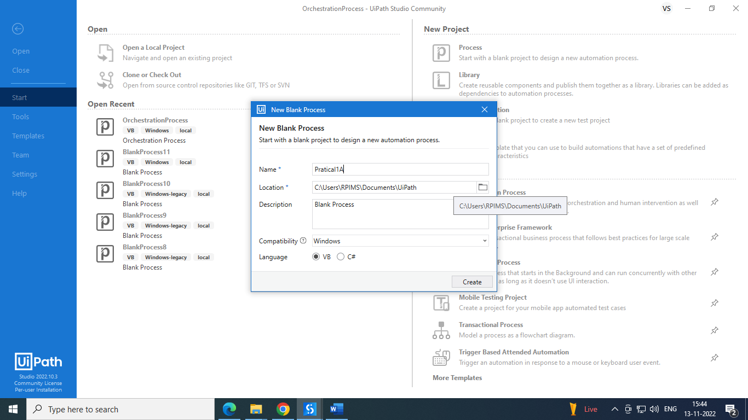

2) Open Main.xaml from Project tab. On the Designer panel, double click a Sequence activity from the Activities panel.

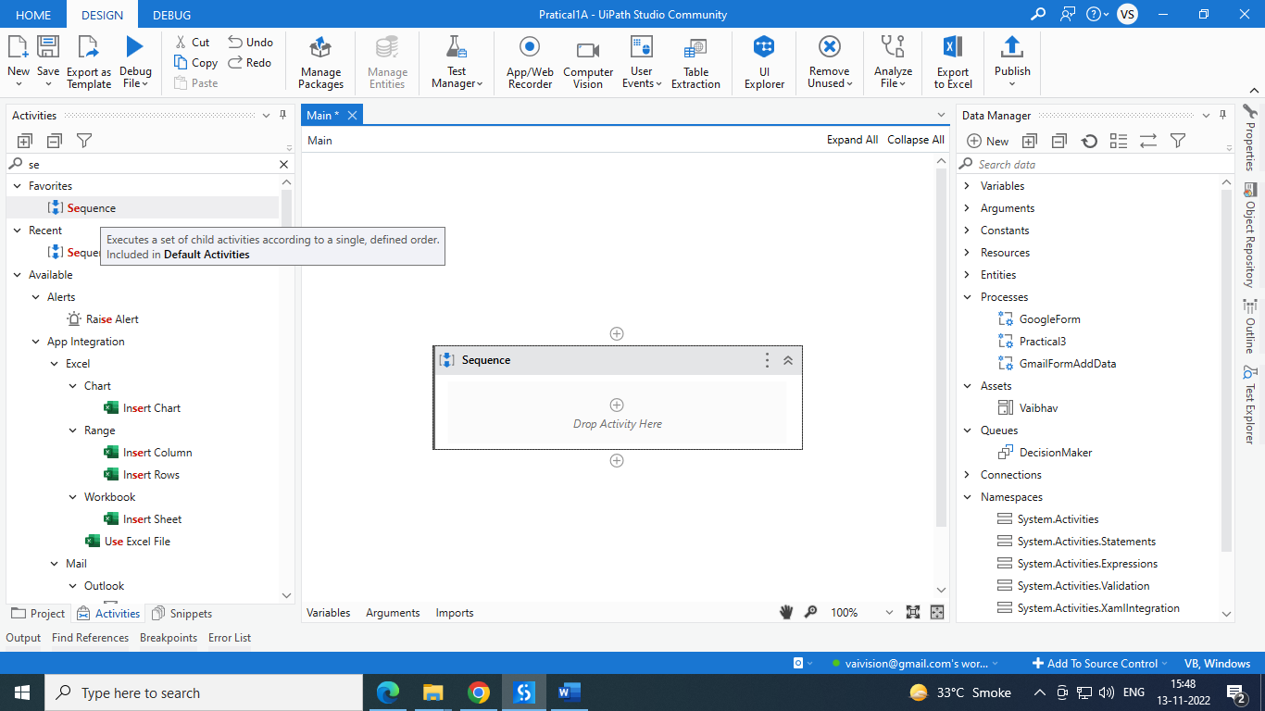

3) Select Variable tab from bottom of page. Create variable x and y and select variable data type as int32 and save.

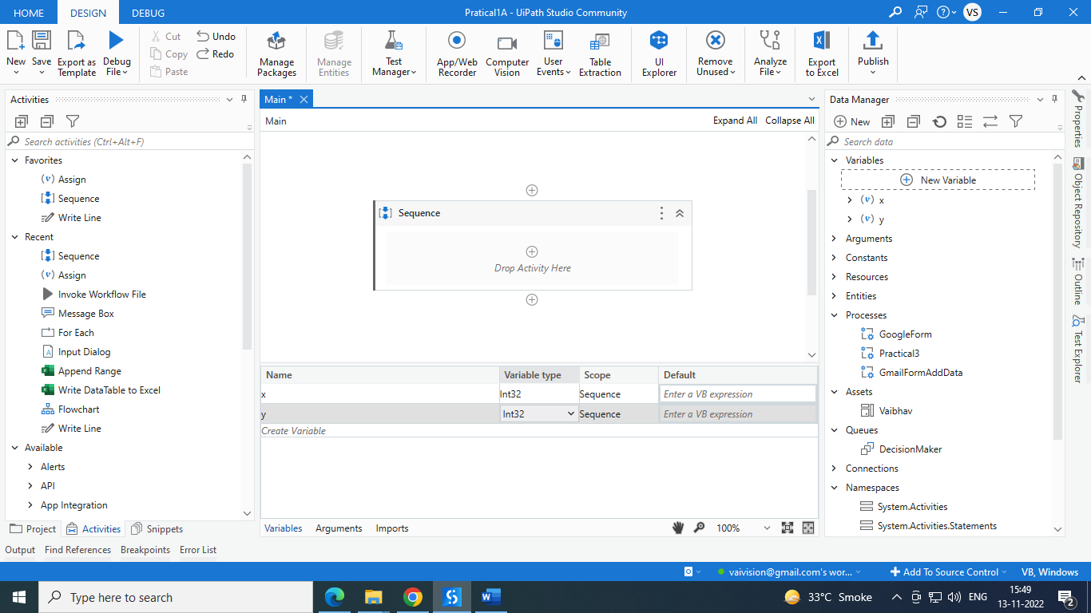  
4) Select and drag input dialog from activities. Fill all data labels. Add entered value x and y variable respectively. As below.

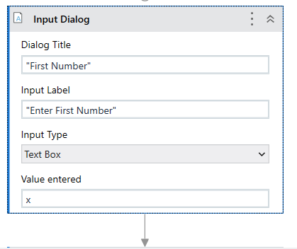

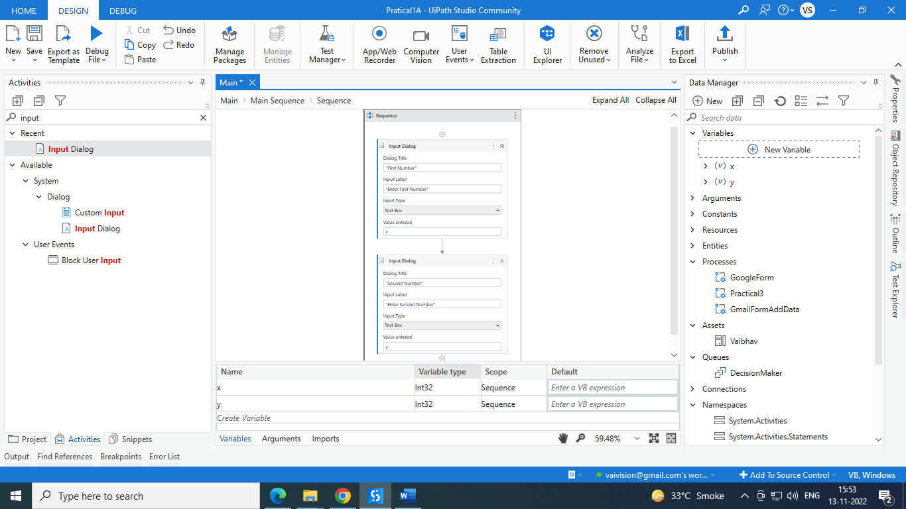

5) select and drag Messagebox from activity menu. Write x+y and save.

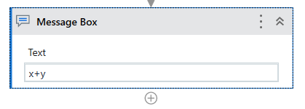

6) Run project and check.

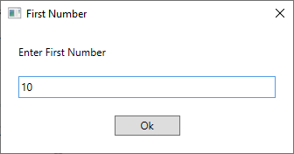

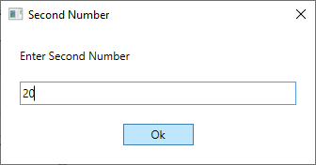

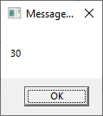

**1.B) Create a simple flowchart-based project.**

**Aim: Create project to show ODD and even using flowchart.**

1. Open UiPath Studio and click on Blank to start a fresh project. Give it a meaningful name. Like Pratical1B.

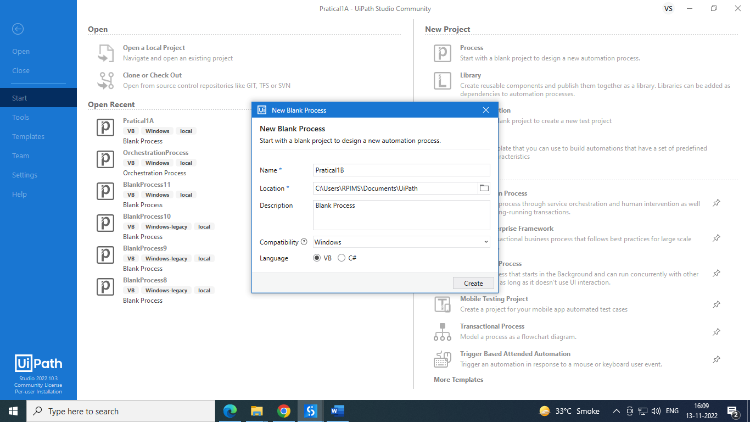

2) Open Main.xaml from Project tab. On the Designer panel, double click a flowchart activity from the Activities panel.

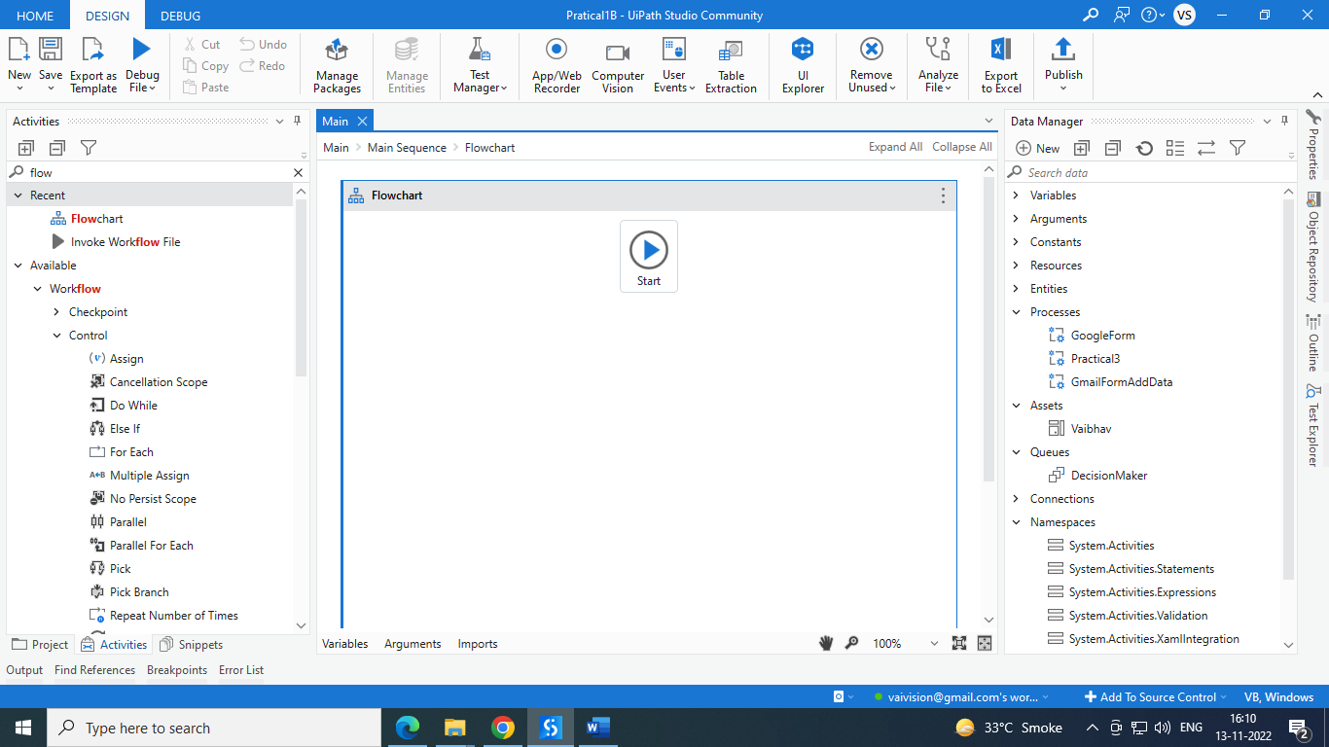

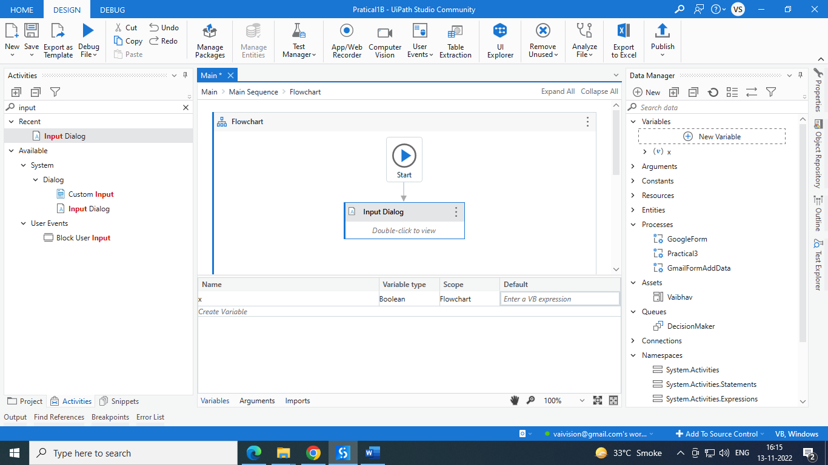

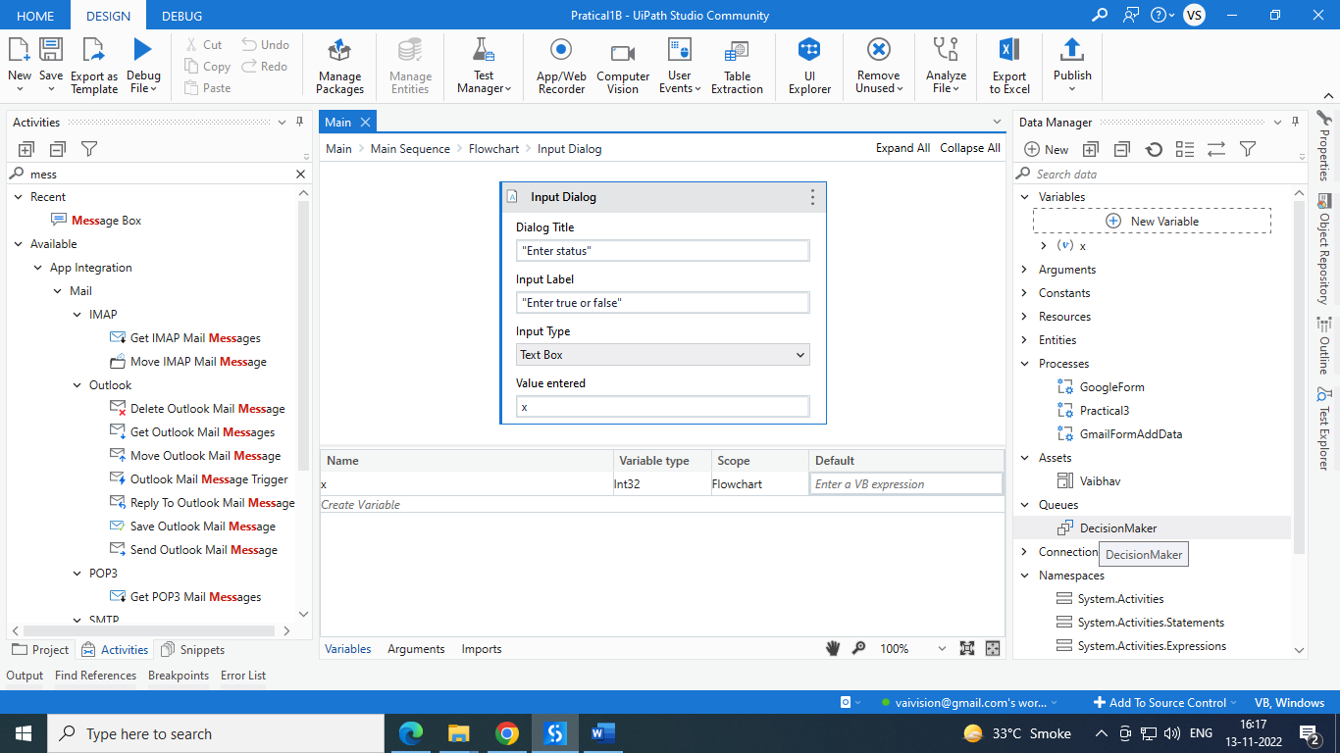

Add next activity flow decision. Set condition like (x mod 2=0) in properties selection.

Add two more message box and connect with true and false flow. And give even number is its true. Give odd number if its false.

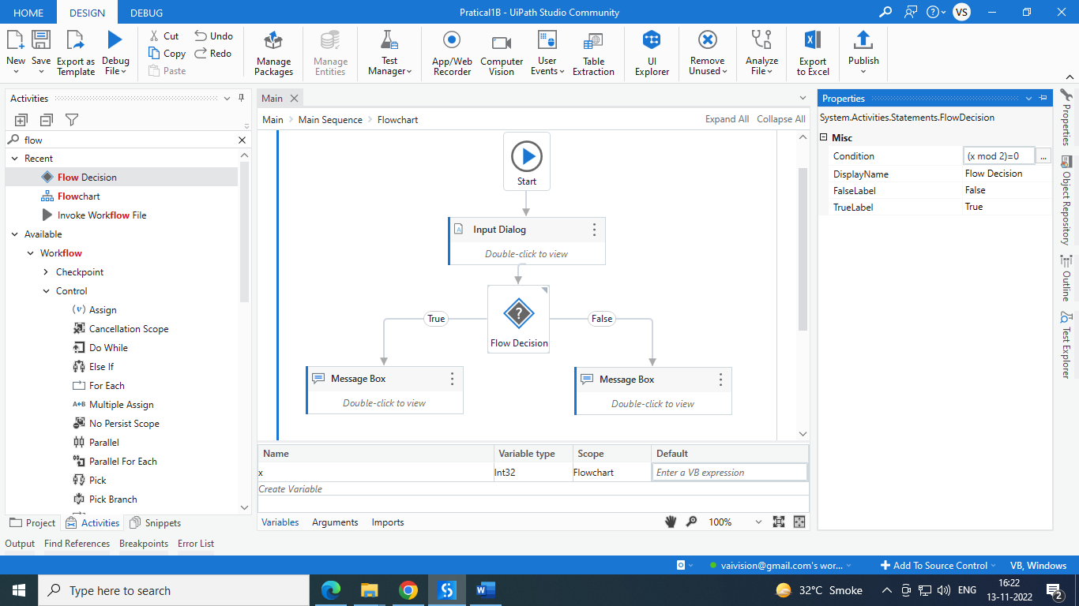

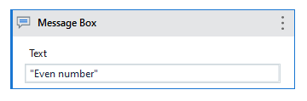

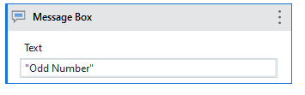

**O/P:**

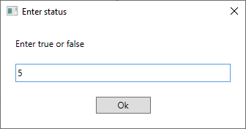

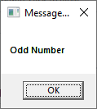

**C. Automate UiPath Number Calculation (Subtraction, Multiplication, Division of numbers).**

Steps: 1. Open UiPath Studio and click on Blank to start a fresh project. Give it a meaningful name

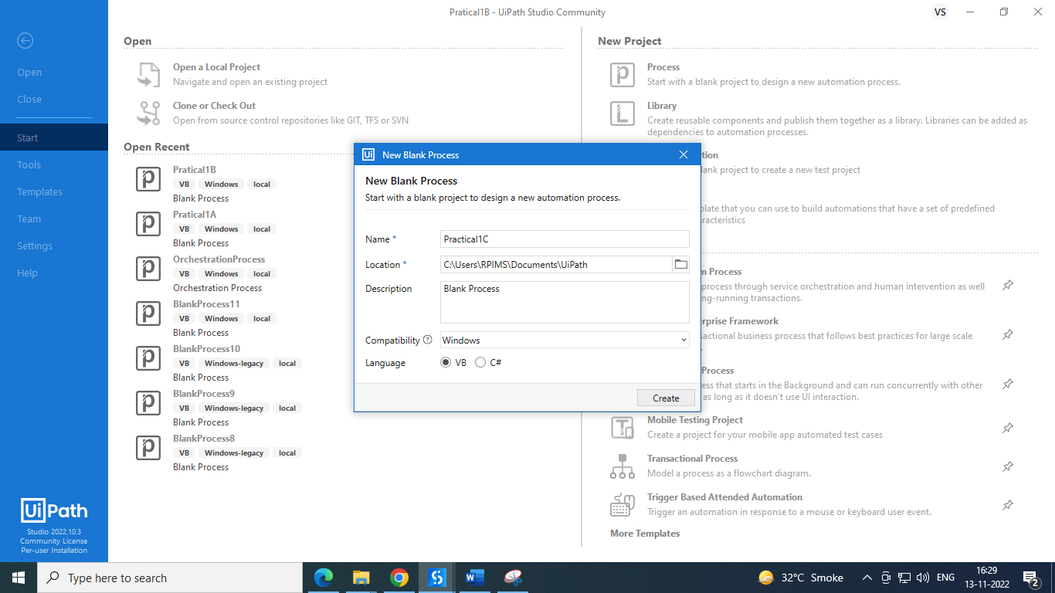

Add sequence on page then Select 2 input dialog for two number from activity panel and create variable x and y with int32 datatype.

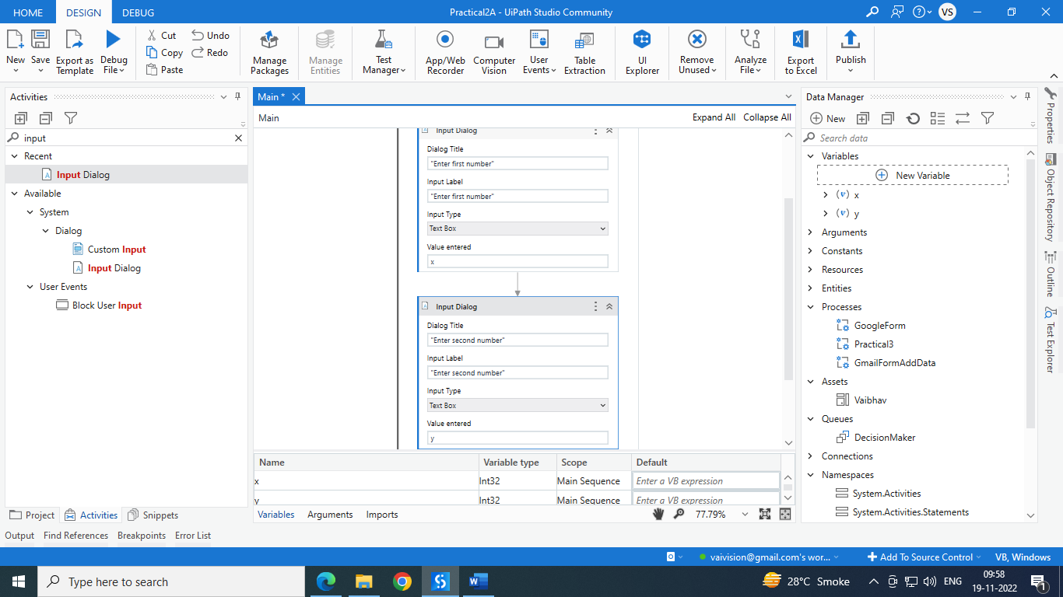

Select another Input dialog for selecting operation like addition, subtraction, division and multiplication, which data stored in Z variable which is string datatype.

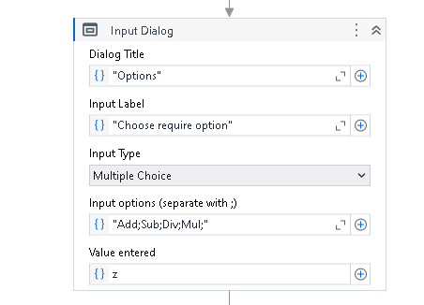

Select **if** activity from activity window, then add 1 message box from activity for addition.

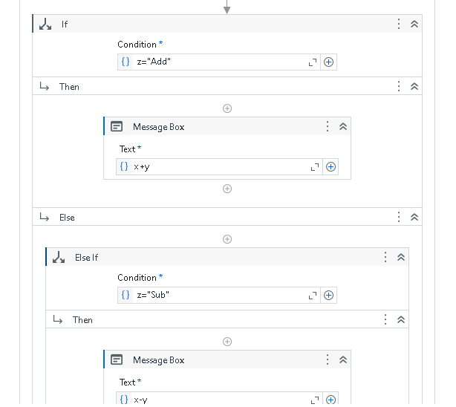

And add subtraction, division and multiplication in **Else-if** activity.

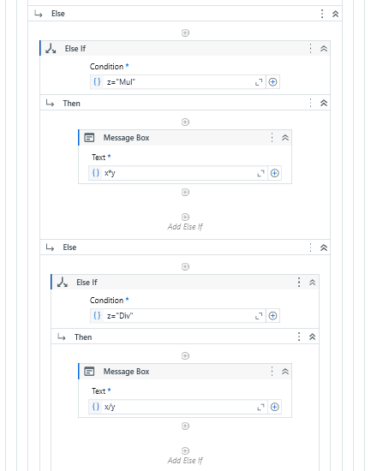

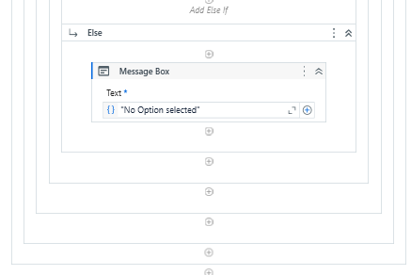

O/p:

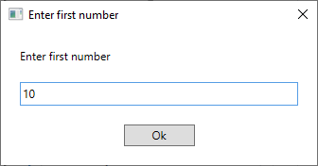 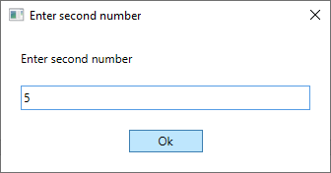

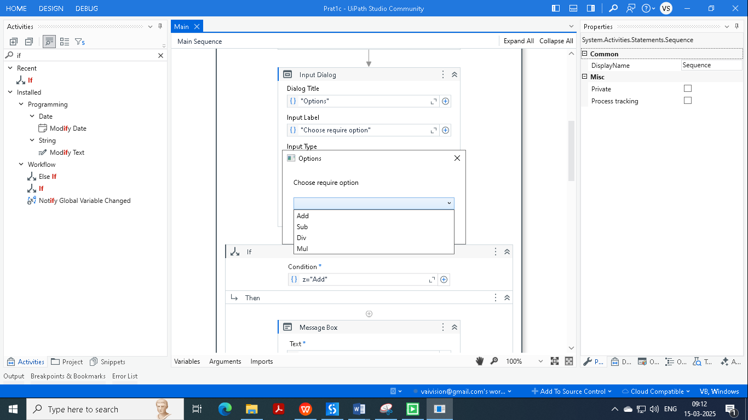

When we choose addition then it will show below message box.

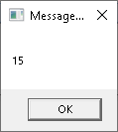

**d. Create an automation UiPath project using different types of variables (number, datetime, Boolean, generic, array, data table).**

**Steps:**

Follow steps as above to create project. Also give appropriate name.Create variable as below.

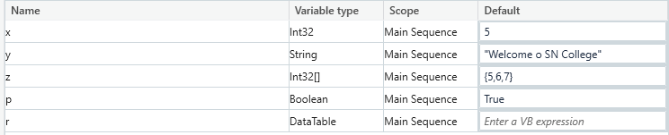

Create data table from Build Data table. As per blow screenshot.

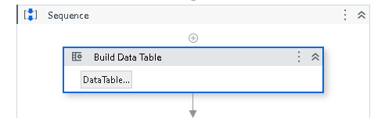

Click on data table and create data like

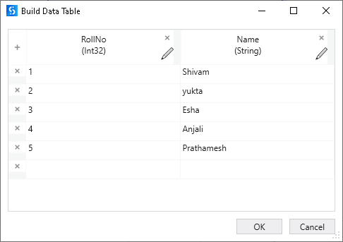

Also add message box to show Integer and string data.

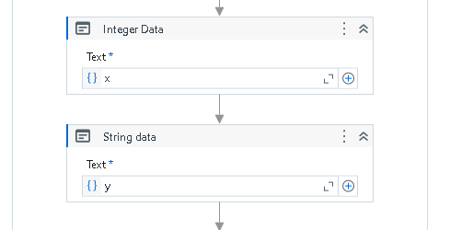

Add for each activity for Integer array to display array data.

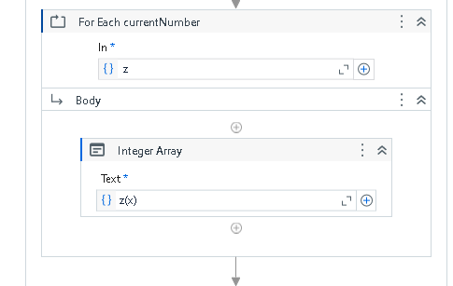

For Boolean data add message box out side of for each.

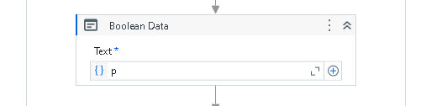

Add for each table to fetch data from data table. Instead of CurrentRow(0) write CurrentRow.Item(0).ToString & CurrentRow.Item(1).ToString.

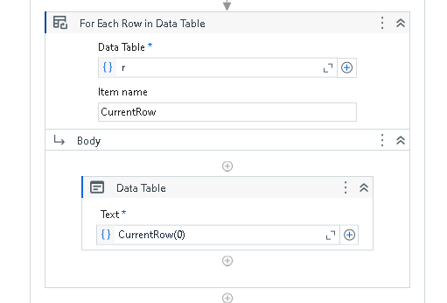

**O/p:**

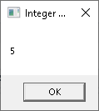 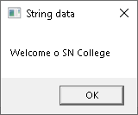

Integer Array:

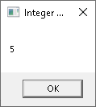 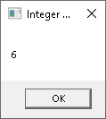 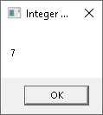

Boolean Data:

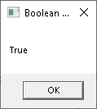

Datatable Data:

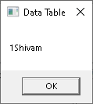 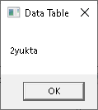 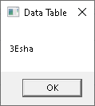 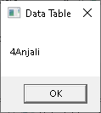 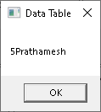

**Practical 2 : Decision making and looping**

1. Consider an array of names. We have to find out how many of them start with the letter "a". Create an automation where the number of names starting with "a" is counted and the result is displayed.

Step 1: Open UI path and create new project with appropriate name and choose language type VB.

Step 2: Add sequence in project from activity panel. Create variable “names”. Variable type Array of [T] String.

Default values {"vijay","ajay","rahul","ashish","arman","akash","vipul"}.

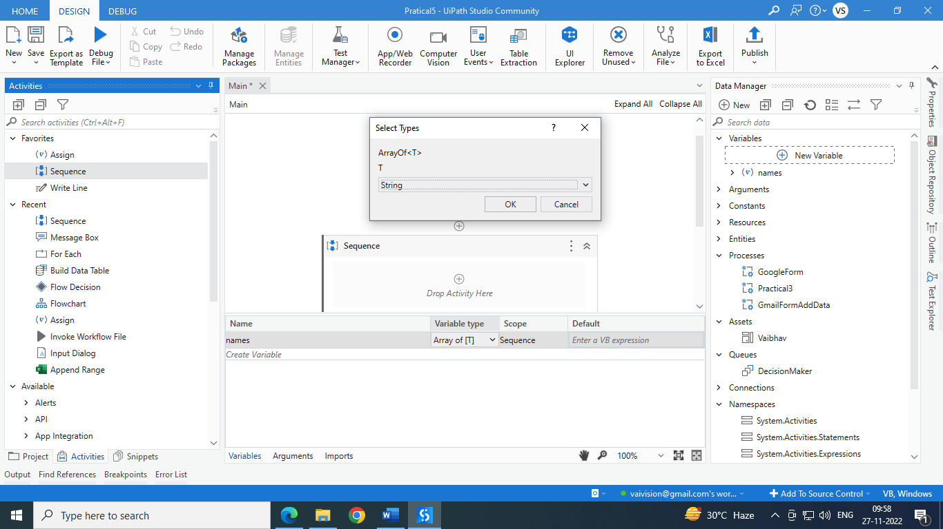

Add “for each” from activities panel. In = names

Add if inside “for each”. Add condition like currentItem.ToString.StartsWith("a").

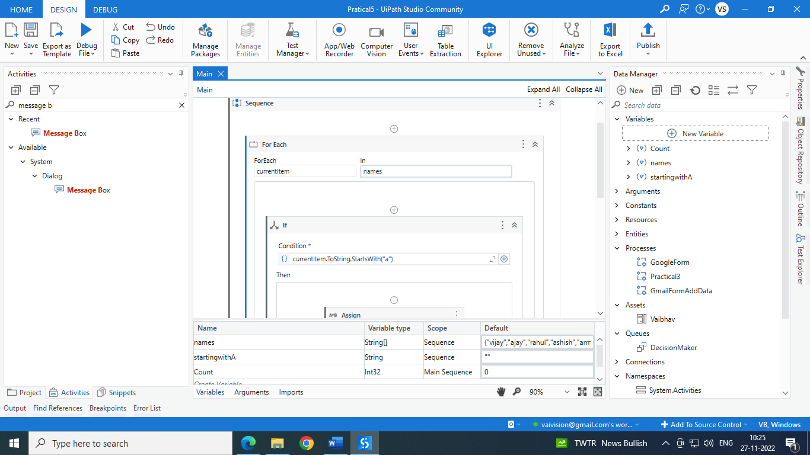

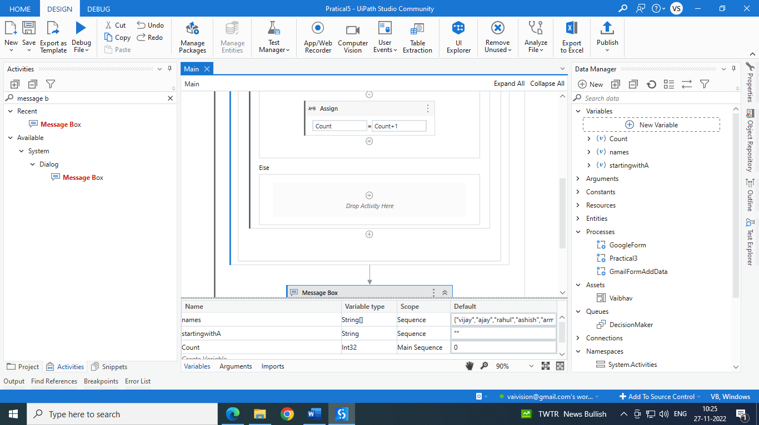

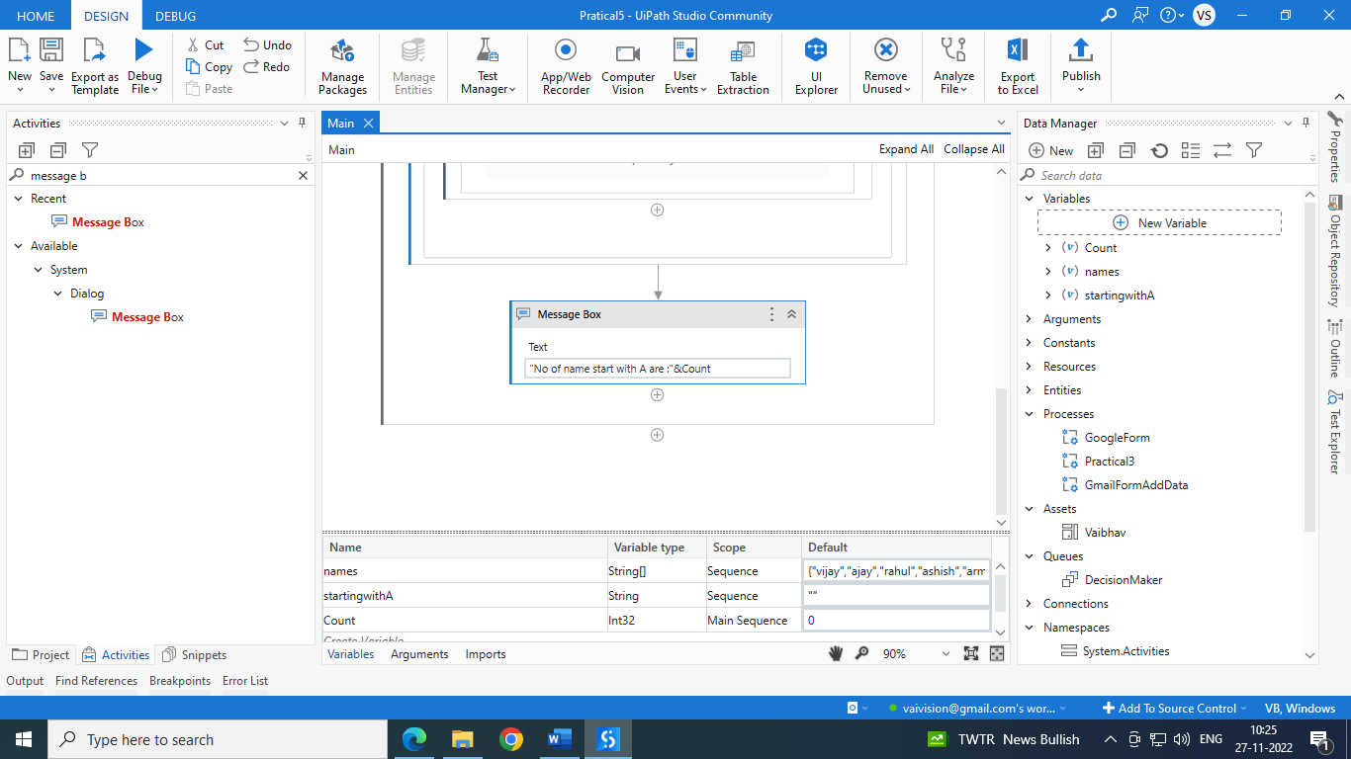

o/p:

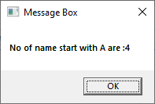

**2b. Demonstrate switch statement with an example.**

Step 1: Open UI path and create new project with appropriate name and choose language type VB.

Step2: Select Classic Input dialogbox from the activity window and drop into sequence also fill below details.

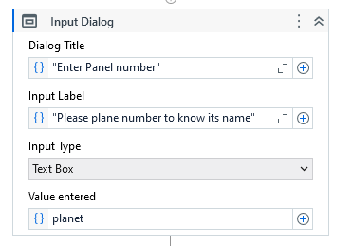

Create planet as a variable as below.

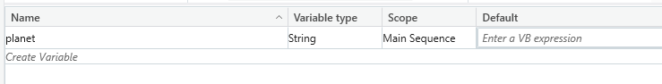

Step 3: Select switch activity from activity window and drop into sequence and add cases according to below text input. Choose message box activity to display message.

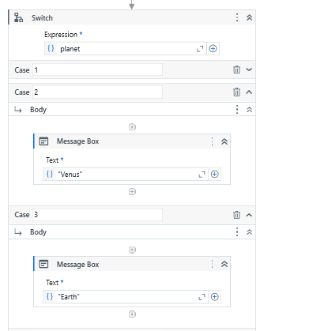

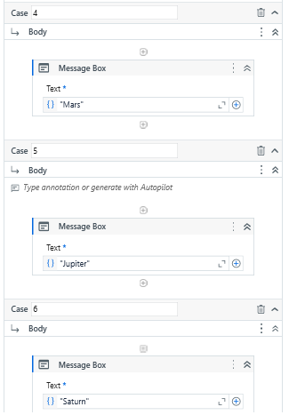

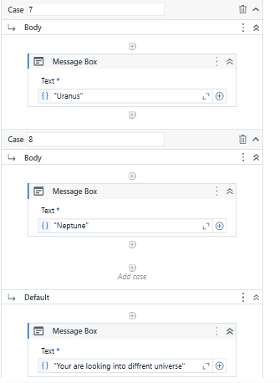

**O/P :**

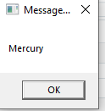 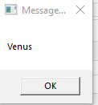 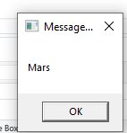

**2c.Create an automation To Print numbers from 1 to 10 with break after the writeline activity inside for each activity**

Step 1: Open UI path and create new project with appropriate name and choose language type VB.

Create variable x and give value as below.

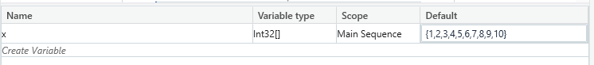

Step 2: Select For each activity from the activity window and drop into sequence also fill below details.

Step 3: Select write Line activity from the activity window and drop into sequence and give “size of integer array” as text input.

Step 4 : Select Break activity from the activity window and drop into sequence to break the loop.

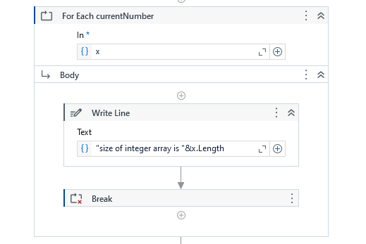

Step 5 : Select Write Line activity from the activity window and drop into sequence to display output as string.

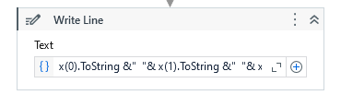

**O/P :**

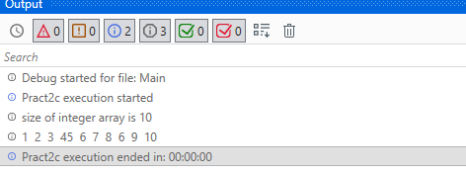

**2d. Create an automation using Do..While Activity to print numbers from 5 to 1.**

Step 1: Open UI path and create new project with appropriate name and choose language type VB.

Create variable x and give value as below.

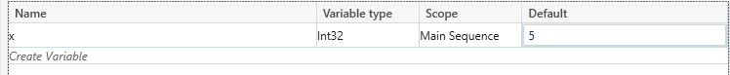

Step 2: Select Do While activity from the activity window and drop into sequence also fill below details. Select message box activity and give x variable as input.

Step 3 : Select Assign activity from the activity window and drop into sequence and give value to save as

x-1 with condition that that x > 0.

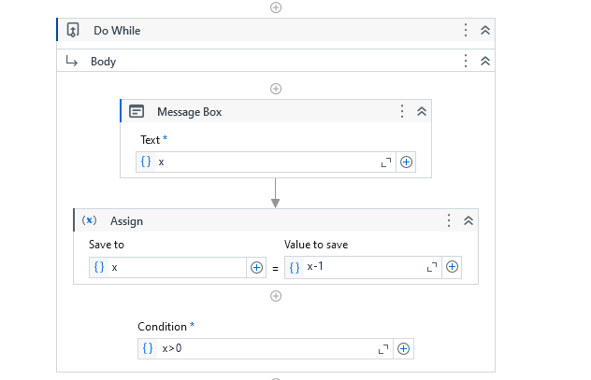

**O\P:**

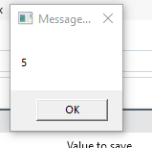 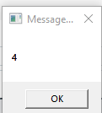 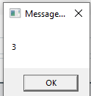 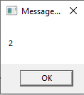 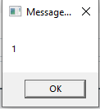

**2e.Create an automation using Delay Activity between two writeline activities to separate their execution by 5 seconds.**

Step 1: Open UI path and create new project with appropriate name and choose language type VB.

Create variable x and give value as below.



Step 2: Select Do While activity from the activity window and drop into sequence also fill below details. Select message box activity and give x variable as input.

Step 3 Select Delay activity from the activity window and drop into sequence to delay the output message by 5 seconds.

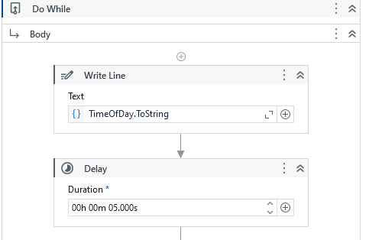

Step 4 : Select Assign activity from the activity window and drop into sequence and give value to save as

x-1 with condition that that x > 0.

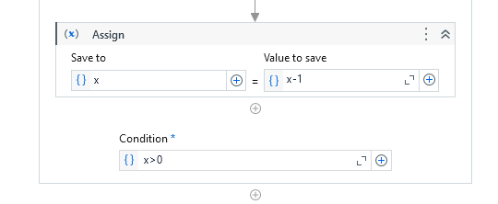

**O\P:** The output will be displayed with 5 seconds of delay.

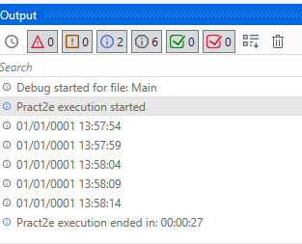

**2f. Create an automation to demonstrate use of decision statements (if).**

Step 1: Open UI path and create new project with appropriate name and choose language type VB.

Create variable x and give value as below.

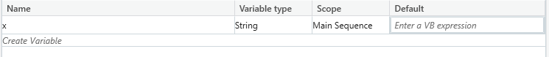

Step 2 : Select Input Dialog activity from the activity window and drop into sequence. Give Dialog Tittle, Input Label, Input Type as below and enter value as variable x.

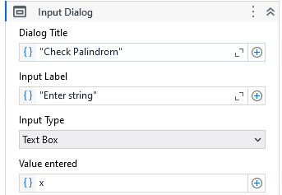

Step 3 : Select If activity from the activity window and drop into sequence to give a condition.

If x is equal to reverse of string of x then the message box will display output as : “Entered String is Palindrome.”

Else it will display : “ Entered string is not palindrome”.

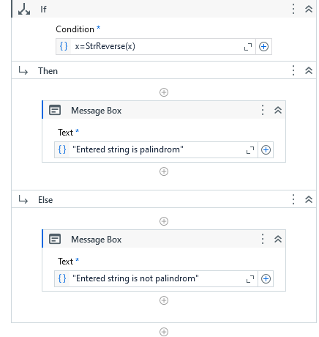

**O/P :**

